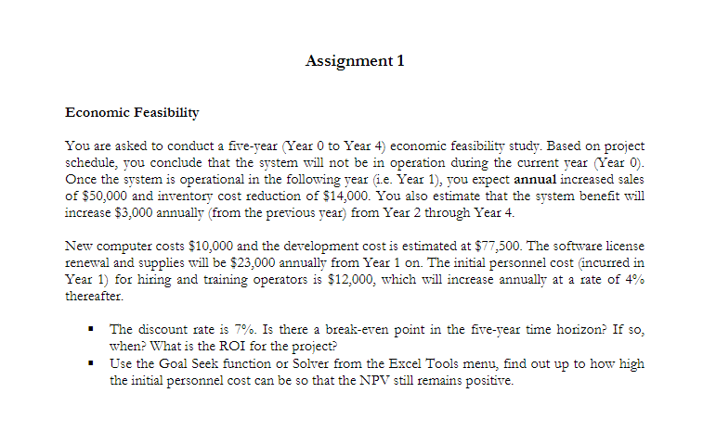

Let’s figure out cash flow. 1 cost in year 0 = computer + development = 10,000+ 77,500 = 87,500

Annul TB = Increased sale + Inventory cost reduction = 50,000 + 14,00 = 64,000.

Starting year 2, TB in year N = TB first + 50000+14000+3000 – 23000 – 12000*1,04

And then see the excel table below

|  |  |
| --- | --- |
| 0 - 1 | -87500 |
| 1 - 2 | -35500 |
| 2 -3 | -3980 |
| 3 - 4 | 27540 |
| 4 -5 | 59060 |

The break even is existing in the five year horizon, after3 years.